|  |
| --- |
|  |
| 新概念 3 册 |
| Lesson25 |

Lesson 25 The Cutty Sark

**impressive [ɪm'presɪv] adj. 给人以深刻印象的**

an impressive ceremony / building / speech / performance … The girl was very impressive in the interview.

impress sb. with / by sth.

The girl impressed her fiancé's family with her liveliness and sense of humor. We were most impressed with / by your efficiency.

I had no intention of buying one, but I could not conceal the fact that I was impressed by the size of the diamonds.

give sb. the impression that …

The sudden movement of the door made it sway slightly and it gave me the impression that it was about to leap out at me.

have / get the impression that …

I had the distinct impression that I was being followed.

be under the impression that ...

Though the crew were at first under the impression that the lost ship had been found, the contents of the chest proved them wrong.

era ['ɪərə]

**n. 时代，时期**

**era / epoch**

the Victorian / Clinton era / epoch

the steam-engine / post-war era / epoch

We live in an era / epoch of breathtaking change.

the beginning / dawn / dawning of a new era / epoch be on the threshold of a new era / epoch

the end of an era / epoch

It marked the end of the great tradition of ships with sails and the beginning of a new era. His death marked the end of an era.

in modern / recent / ancient / prehistoric times

in times of …

in times of peace / war

In times of peace, when business was bad, Hawkwood and his men would march into a city-state …

age

the Bronze / Ice / Stone Age the modern / computer age

In this age of the Internet, finding a job can be much easier.

The nomads who made these markings lived by hunting and fishing during the last Ice Age, which began about 35,000 B.C. and ended about 10,000 B.C.

rudder ['rʌdə(r)]

**n. 舵**

rudder 舵 anchor 锚

mast 桅杆 deck 甲板

hull 船体 cabin 船舱

bow 船头 stern 船尾

port 左舷 starboard 右舷

roll [rəʊl]

**v. 滚动；卷起；摇摆； 发出隆隆声**

Tears rolled down her cheeks. The ball rolled down the hill. rolling stone

a rolling stone gathers no moss

George took off his jacket, rolled up his sleeves and pushed his right arm through the drain cover. The ship was rolling heavily to and fro.

The Cutty Sark rolled from side to side and it became impossible to steer her. Thunder rolled in the distance.

a roll of carpet / film / cloth spring roll

The teacher called the roll.

Three senators missed the roll call.

The slow, steady roll of the ship made us feel sick. the distant roll of thunder

steer [stɪə(r)]

**v. 驾驶**

This car is very easy to steer.

He steered the boat into the harbor.

drive

Can you drive? He drives a taxi. **ride**

I ride a bicycle to work every day.

pilot

The captain piloted the boat into a mooring.

She piloted the aircraft to safety after one of the engines failed.

fly

Only experienced pilots fly large passenger aircraft.

be at / behind the wheel

Who was at the wheel when the car crashed?

One man stayed at the wheel while two others with black stockings over their faces jumped out and smashed the window of the shop with iron bars.

temporary ['temprəri]

**adj. 临时的，暂时的，非永久的**

a temporary job

a temporary measure

temporary relief from pain temporarily

She's only working here temporarily.

Only an exceptionally heavy snowfall might temporarily dislocate railway services.

permanent

a permanent job

my permanent address

My cousin, Harry, keeps a large curiously shaped bottle on permanent display in his study. permanently

She had decided to settle permanently in France. provisional

a provisional government provisionally

The meeting has been provisionally arranged for 3 p.m. next Friday.

contemporary

contemporary music / art / dance



Marlowe was contemporary with Shakespeare. Marlowe and Shakespeare were contemporaries. **fit [fɪt]**

v. 安装；适合

**fit sth. on / to sth.**

I need to fit a lock on the bathroom door. Anti-theft devices are fitted to all our cars. **be fitted with sth**

The windows and doors are all fitted with security locks.

It has to be tall because it is like a giant block and tackle, and we have to lower into the ground and haul out of the ground great lengths of drill pipe which are rotated by an engine at the top and are fitted with a cutting bit at the bottom.

The uniform fitted her perfectly .

The punishment should fit the crime.

This card just fits nicely into that envelope.

I was not surprised to find that the machine still refused to work after I had reassembled it, for the simple reason that I was left with several curiously shaped bits of metal which did not seem to fit anywhere.

I swim twice a week to try and keep fit.

be fit for

**be fit to do sth**

This book is not fit for publication! He is not fit to govern this country!

But Alfred had deduced that the Danes were no longer fit for prolonged battle: …

Chickens slaughtered in the United States, claim officials in Brussels, are not fit to grace European tables.

delay [dɪ'leɪ]

**v. & n. 耽搁；推迟，延期**

We must leave without delay.

There was a delay of two hours before the plane took off. You’ll be late if you delay.

I was delayed by the traffic.

delay / postpone sth. until …

The match had to be delayed / postponed until next week.

delay / postpone sth. for …

Our meeting was delayed / postponed for ten minutes.

delay / postpone doing sth.

It was an unpopular decision to delay / postpone building the new hospital.

bring / put sth.⇔forward to …

The meeting has been brought / put forward to Thursday.

One of the most famous sailing ships of the 19th century, the Cutty Sark, can still be seen at Greenwich.

in the early / middle / late 19th century

at the turn / dawn / beginning of the 19th century at the end of the 19th century

The loss of the Titanic the Cutty Sark

the Vasa

The great ship, Titanic, sailed for New York from Southampton on April 10th, 1912.

The small ship, Elkor, which had been searching the Barents Sea for weeks, was on its way home. One of the most famous sailing ships of the 19th century, the Cutty Sark, can still be seen at Greenwich.

GMT: Greenwich Mean Time

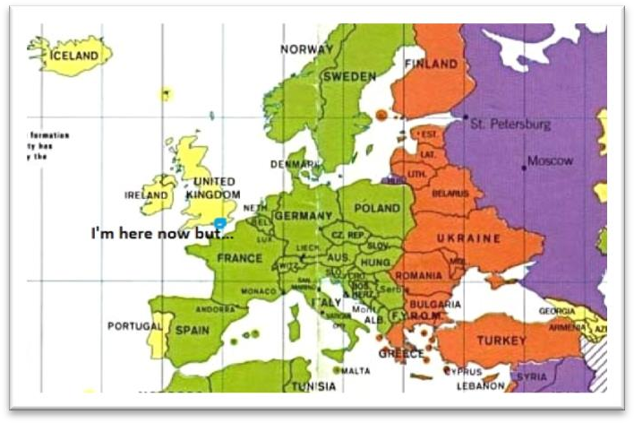

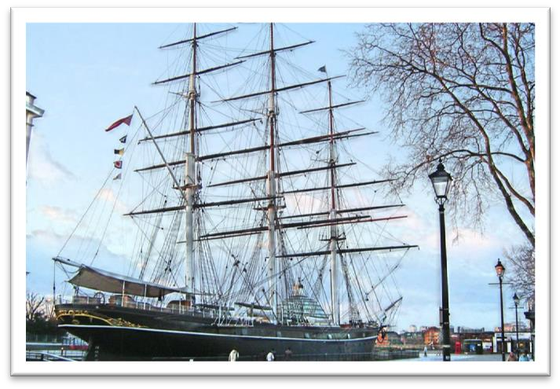

**指“车、船、祖国”时常用 “she”**

She was carrying 1,316 passengers and crew of 891. What’s wrong with my car? She won’t start.

China has done what she promised to do.

serve as

This room can serve as a study.

Her death should serve as a warning to other young people.

Not all sounds made by animals serve as language, …

act as … function as …

A five-year sentence should act as a deterrent to others. Some English adverbs function as adjectives.

reminder (souvenir memo …)

Alison's story is a reminder of how vulnerable women can be in what is still essentially a man's world.

serve / act as a reminder = be a reminder

The drop in stock prices serves / acts as a reminder that investing is a form of gambling. The accident served / acted as a timely reminder of just how dangerous speeding can be.

Before they were replaced by steam-ships, sailing vessels *like the Cutty Sark* were used to carry tea from China and wool from Australia.

replace

Robots are replacing people on assembly lines.

be replaced by …

Before they were replaced by steam-ships, sailing vessels like the Cutty Sark were used to carry tea from China and wool from Australia.

The old farmhouse the family lived in was to be replaced by a new $500,000 home.

steamship

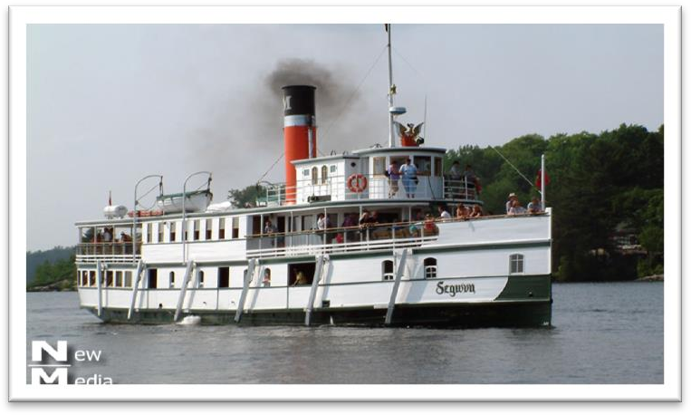

sailing ships sailing vessels ships with sails **be used to do be used to doing used to do**

At that time, however, she was not only *the largest ship* that had ever been built, but was regarded as unsinkable, for she had 16 watertight compartments.

one of + 复数名词 + who / which / that + 谓语动词（单复数均可）

The Cutty Sark was one of the fastest sailing ships that *has* ever been built.

One of the things that *fascinates* us most about cats is the popular belief that they have nine lives.

Jasper White is one of those rare people who *believes* in ancient myths.

John is the only one of the students in the class (A) that never (B) admit making a mistake even when (C) it is (D) pointed out to him.

John is *the* only *one* of the students in the class (A) that never (B) admit making a mistake even when (C) it is (D) pointed out to him.

John is *the* only *one* of the students in the class that never admits making a mistake even when it is pointed out to him.

The only other ship to match her was the Thermopylae.

**match v. 与……相匹敌，是……的对手**No one can match the unknown archer. The two teams are well matched. **match … in / for …**

You can’t match him in knowledge of wild plants. But nothing can match them for speed and comfort.

The hotel can’t be matched for good service and food.

Both these ships set out *from Shanghai* on June 18th, 1872 on an exciting race to England.

set out / off start out / off

Four days after setting out, while the Titanic was sailing across the icy waters of the North Atlantic, a huge iceberg was suddenly spotted by a look-out.

After making a short test flight at 4.15 a.m., Bleriot set off half an hour later.

One afternoon she set out from the coast in a small boat and was caught in a storm. She is going to set out from the French coast at five o'clock in the morning.

Dressed up as Father Christmas and accompanied by a 'guard of honour' of six pretty girls, he set off down the main street of the city riding a baby elephant called Jumbo.

set out to do

The journalist immediately set out to obtain these important facts, but he took a long time to send them.

Dimitri at once set out to find the thief.

True eccentrics never deliberately set out to draw attention to themselves.

Several people complained of ‘cat-like noises’ at night and a businessman on a fishing trip saw the puma up a tree.

While on a walking tour with his wife, he stopped to talk to a workman.

Both these ships set out from Shanghai on June 18th, 1872 on an exciting race to England. We started out on a 20-mile walk.

She had come on a visit to England.

After a day or so we will go on an excursion.

This race, which went on for exactly four months, was the last of its kind.

go on

Peace negotiations are still going on.

His speech went on for so long that people began to fall asleep.

It marked the end of the great tradition of ships with sails and the beginning of a new era.

the beginning / dawn / dawning of a new era / epoch

The race was a landmark in the history of shipping.

造句：中华人民共和国的成立标志着新民主主义革命 (the new-democratic revolution) 的结束和社会主义革命和建设的新时代的开始。

The foundation of the People’s Republic of China marked the end of the new-democratic revolution and the beginning of a new era of the socialist revolution and construction.

The first of the two ships *to reach Java* after the race had begun was the Thermopylae, but on the Indian Ocean, the Cutty Sark took the lead.

The first of the two ships that reached Java after the race had begun was …

the first, the second, the next, the last, the best, the only … 后常跟不定式作定语

When he landed near Dover, the first person to greet him was a local policeman.

The Swedes were the first to recognize that public officials like civil servants, police officers, health inspectors or tax-collectors can make mistakes or act over-zealously in the belief that they are serving the public.

You are the second to ask me that question.

The next man to approach me was selling expensive pens and watches. The last creature to compete with man was the mosquito.

The pie committee decided that the best way to transport the dish would be by canal, so they insured it for the trip.

The only other ship to match her was the Thermopylae.

The first of the two ships to reach Java after the beginning of the race was the Thermopylae, the lead

take (over) the lead (from …) lose the lead (to …)

…, but on the Indian Ocean, the Cutty Sark took (over) the lead from the Thermopylae.

…, but on the Indian Ocean, the Thermopylae lost the lead to the Cutty Sark . Because of this, the Cutty Sark lost her lead.

be in the lead

**go / move into the lead**

She was in the lead from start to finish.

With a final burst of speed she went / moved into the lead.

*It* seemed certain that she would be the first ship home, but *during the race* she had a lot of bad luck.

It looked / seemed / appeared certain that …, but …

It looked / seemed / appeared *as if / as though* …, but …

It looked / seemed / appeared *as if / as though* she would be the first ship home, but during the race she had a lot of bad luck.

造句：看似肯定会有一场激动人心的穿越海峡的竞速比赛了，但是莱瑟姆未能起得足够早。

It looked / seemed / appeared certain that there would be an exciting race across the Channel, but Latham failed to get up early enough.

造句：看似好像会有一场激动人心的穿越海峡的竞速比赛了，但是莱瑟姆未能起得足够早。It looked / seemed / appeared *as if / as though* there would be an exciting race across the Channel, but Latham failed to get up early enough.

It was an incredible piece of luck. With a bit of luck, we'll finish on time.

Often there is an element of luck in getting the right answer.

bad / ill / rotten / tough luck

The team has had a run of bad luck lately, losing their last five games.

strike (struck struck)

The big clock which used to strike the hours day and night was damaged many years ago and has been silent ever since.

One of the thieves was struck by a heavy statue, but he was too busy helping himself to diamonds to notice any pain.

it strikes sb. that …

It suddenly struck Mrs. Richards that it must be the man from the Electricity Board who had come to read the meter.

Most people were fast asleep when the earthquake struck.

be caught in …

We were caught in a heavy storm / a traffic jam.

heavy / severe / violent / devastating / disastrous storm

In August, she was struck by a very heavy storm and during the storm her rudder was torn away. In August, she was struck by a very heavy storm during which her rudder was torn away.

A week before, he had completed a successful overland flight during which he covered twenty-six miles.

As long ago as the 1930’s, the Red Army had completed the successful Long March during which they covered 25,000 li.

tear sth. away / off / up …

The flag was torn away from the pole by the strong wind. High winds nearly tore the roof off.

The storm had torn the old tree up by the roots. roll heavily / violently *from side to side / to and fro* The ship was rolling heavily to and fro.

The plane rolled violently from side to side in the storm.

from side to side

His few material possessions make it possible for him to move from place to place with ease.

read sth. from cover to cover sell sth. from door to door vary from person to person improve from day to day

**on board**

Before she had anchored, the men from the boats had climbed on board and the decks were soon covered with colourful rugs from Persia, silks from India, copper coffee pots, and beautiful hand-made silver-ware.

spare

a spare key / battery / tire …

A temporary rudder was made on board from spare planks and it was fitted with great difficulty (=very difficultly).

The Officer went through the case with great care (=very carefully).

This greatly reduced the speed of the ship, for there was a danger *that if she travelled too quickly, this rudder would be torn away as well*.

there is / was a danger that …

There was a danger that the wave would rebound off the other side of the bank and send the dish plunging into the water again.

There is a danger that the political disorder of the past will return.

There is a danger that museums will attempt to entertain rather than educate.

造句：如果 Ramsay 夫人报警，她可能就再也看不到 Rastus 了。

There was a danger that if Mrs. Ramsay went to the police, she would never see Rastus again. Because of this, the Cutty Sark lost her / the lead to the Thermopylae.

Because of this, the Thermopylae took (over) the lead from the Cutty Sark.

After crossing the equator, the captain called in at a port *to have a new rudder fitted*, but *by now*

the Thermopylae was over 500 miles ahead.

equator

**pole the North / South Pole latitude longitude axis**

call in at somewhere call in on sb.

Will you call in at the supermarket for some eggs and milk? Could you call in on Mum on your way home?

by now

I had expected to be near my objective by now, but everything still seemed alien to me.

…, but by now the Thermopylae was over 500 miles ahead (of the Cutty Sark / her).

Though the new rudder was fitted at tremendous speed, it was impossible for the Cutty Sark to win.

speed 做不可数名词时，与 at, with 搭配均可

e.g. at / with great speed

speed 做可数名词时，只能与 at 搭配

e.g. at a speed of 60 mph

tremendous

In his day, Mendoza enjoyed tremendous popularity. at (a) fantastic speed

Four days after setting out, while the Titanic …

Three days after Rastus' disappearance, Mrs Ramsay received an anonymous letter.

A man who had broken his right leg was taken to hospital a few weeks before Christmas.

considering prep. & conj.

Considering the amount she paid, he was dear in more ways than one! Even this was remarkable, considering (that) she had had so many delays.

There is no doubt that *if she had not lost her rudder* she would have won the race easily.

there is no doubt that …

There's no doubt that one day a cure will be found.

undoubtedly

She was undoubtedly the best candidate. Undoubtedly, public interest in folk music has declined. **needless to say, …**

Needless to say, the man's name was Hans Bussman and he really was Franz's long-lost brother. Needless to say, the bigger the risk an insurance company takes, the higher the premium you will have to pay.

it goes without saying that …

It goes without saying that home is the warmest place in the world.

It goes without saying that a real sportsman will never dream of cheating in a game.

与过去事实相反的“if”型的虚拟

If + S. + had done, S. + would / should / could / might + have done

If they had only had one more child, the fact *would have passed* unnoticed.

If the Houses of Parliament had not been burned down in 1834, the great clock *would never have been erected*.

… she would have won the Thermopylae easily. X

… she would have beaten / defeated the Thermopylae easily. √

造句：毫无疑问，如果泰坦尼克号没有撞到冰山，她将抵达目的地而毫发无伤 (intact)。There is no doubt that if the Titanic had not been hit by the iceberg, she would have reached her destination intact.